Use case:
List all Malicious WebPages
List All Topics

Register and Login

Add / view Topic Posts


View all recommended WebPages
User
Search WebPages by content keyword and View Malicious web pages
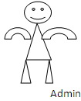
Block Malicious WebPages
User
View all other user recommended Web pages

View Top k web pages ulrs

View Topic ranks in chart, view NO.of time accessed specified malicious web page in chart

